NAME: K.HARSHA

REG NO.:192212017

Experiment no:05

Configuration of meshTopologies using Packet Tracer .

### AIM:

Configuration of mesh Topologies using Packet Tracer.

### REQUIREMENTS

1. Switch/Hub -Interface Between two devices.
2. Cable -Used to connect two devices.
3. End devices- They are the devices through which we can pass

Message from one device to another and the are interconnected.

Procedure:

**STEP**1:Click on the end device, select generic Pc’s drag it on the window .

Click on SWITCH draf and dropit on the window.

**STEP**2: Select the straight through cable and connect all end device to switch.

Assign the IP address for all end devices. (Double click the end device

**STEP**3:NowsettheIPaddresstoHostA(192.168.1.1)instaticmode.SimilarlysetIPaddressforHost B (192.168.1.2)and Host C (192.168.1.3)

**STEP**5:To viewthe IPaddress,give ipconfigcommandin command prompt.Usingpingcommand, wecanestablishcommunication betweentwo hostdevices.

**STEP** 6: Now display the packet transmission in simulation mode.

MESH:

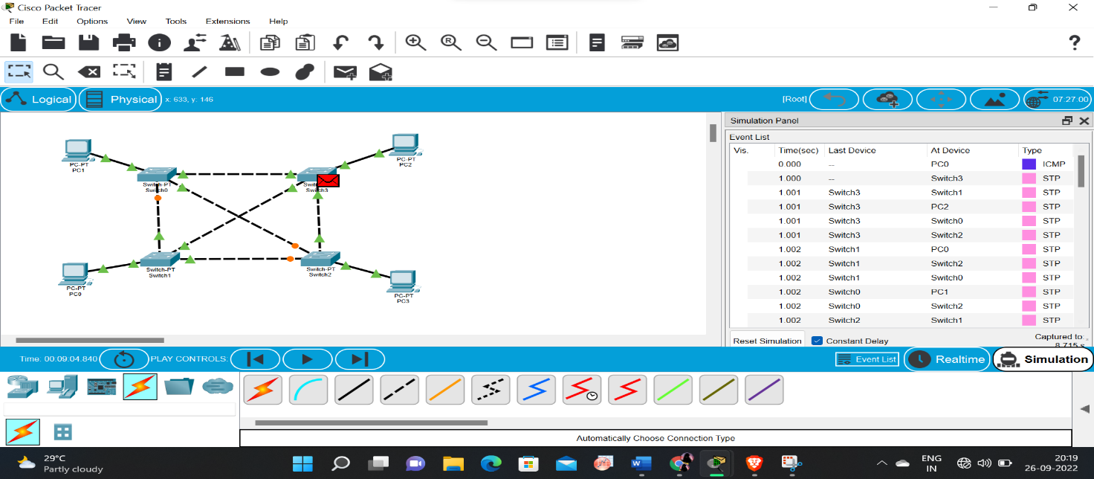

RESULT :  
 Configuration of Mesh Topologies using Packet Tracer communication is verified successful.